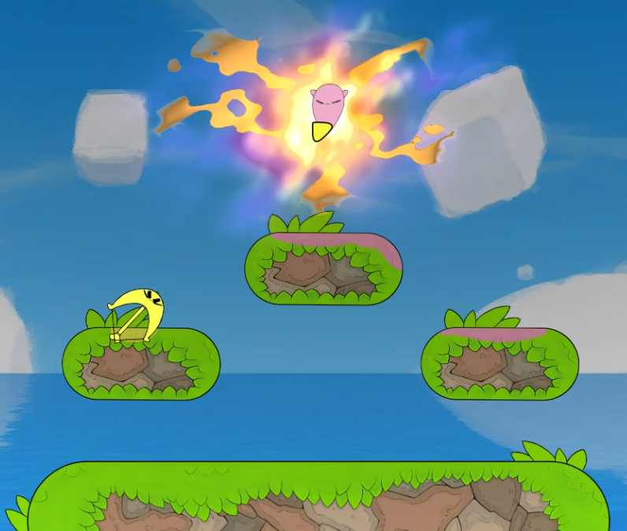
To replicate this 2D scene from Bopl Battle in 3D, we will model the floating grass-covered platforms over water, the pink blob-like character channeling energy with a colorful burst overhead, and the yellow bow-shaped character drawing an arrow below. We will ignore the cursor and focus on shaping the terrain and objects using basic 3D primitives in OpenGL.
We will construct the floating platforms with two vertical cylinders placed at each end to form the rounded edges, connected by a stretched box in the middle to create the oblong main body. This combination gives the platforms their characteristic curved island appearance. We will use a large plane for the water surface to ground the entire scene and provide a base for the platforms to float above.
For the grass tufts covering the platforms, we will place multiple small cones scattered across the tops and edges. We will apply uneven scaling and rotation to the cones to make them appear more organic and voluminous in 3D, rather than relying solely on flat textures.
We will build the pink blob character as a composite object starting with a main sphere for the rounded body, adding a smaller cone on bottom for that iconic tail feature, and attaching additional small spheres or cones to represent the arms this character is using to channel the energy around him.
We will model the yellow bow shaped character using a tapered cylinder for the curved, banana like body. For the bow, we will use half a torus to approximate the main curved frame, or use three thin cylinders if creating a half torus proves impossible. The arrow will consist of a pyramid for the head, a long thin cylinder for the shaft, small boxes fanned out for the fletching, a thin pyramid for the arrow head, and a couple narrow cylinders or textured plane for the string.
We will implement the backdrop with a skybox to create a seamless blue sky environment, allowing flexible camera movement around the scene. If a more restricted side view camera is preferred, a single large plane with a sky texture can be used instead for simplicity.
This approach incorporates six of the distinct basic 3D shapes (cylinder, box, cone, plane, pyramid, and torus), including a plane to ground the objects, several objects made from two or more shapes, and keeps the project achievable while capturing the most interesting parts of the scene.

